Developing a common language for transdisciplinary modelling teams using a generic conceptual framework
S.H. Hamilton ª , W.S. Merritt ^{b} , L. Carter ^{c}, L. Lim-Camacho ^{c} , U. Nidumolu ^{d}, M. Cosijn ^{c},
R. Mishra ^{e}, M. Dash ^{f} and C. Roth ^{c}

ª School of Science, Edith Cowan University, Joondalup, Western Australia, ^{b} Fenner School of Environment and Society, The Australian National University, Australian Capital Territory, ^{c} CSIRO Land & Water, Brisbane, Queensland, ^{d} CSIRO Land & Water, Adelaide, South Australia, ^{e} Centre for Development of Human Initiatives (CDHI), Jalpaiguri, India, ^{f} Shushilan, Khulna, Bangladesh

Email: wendy.merritt@anu.edu.au
Abstract: In developing countries, problems of poverty and the environment are inextricably intertwined, with any potential resolution requiring underlying political, social and economic causes to be addressed. An integrated research approach to examine such problems should not only involve a transdisciplinary team that covers the broad scope and perspective of relevant issues, but also ensure that interactions between different issues are deliberately explored. Differences in theories, methods, terminologies and research interests of team members, often hinders integration and leads to such complex projects being fragmented by disciplines. This paper describes a template for developing a conceptual framework for a project aimed at promoting socially inclusive and sustainable agricultural intensification in West Bengal (India) and southern Bangladesh. The project involves consideration of the various climate, market, environmental, social, political and health risks that threaten the livelihoods of these rural communities. The proposed template was designed to provide a common framework that the team can readily co-develop and thus overcome some of the challenges of working with transdisciplinary teams. This framework underpins the integrated modelling activities of the team.
In our conceptual framework template, processes are described in terms of a change to resources, the direct and indirect drivers of this change, and the direct and indirect impacts of the change. We selected terms that are unambiguous, yet broadly applicable and neutral, avoiding value-judgments. The use of more neutral terms will enable the framework to be used to represent both opportunities and challenges, as well as positive and negative directions of change. It will also help avoid imposing certain perceptions onto others – for example, what is viewed as a risk or disbenefit by some may be viewed as an opportunity or benefit by others. Therefore, the neutral language is more amenable to cross-cultural contexts and teams. A change in resources can include any increase or decrease in tangible and intangible assets, capabilities, capacities, or behaviours. Additional factors can be any factor that affects the rate of change – i.e. one that increases or reduces the magnitude of change or impact, or the capacity of the subject to avoid, cope with or adapt to the specified change. Examples of the use of the template are provided in this paper.
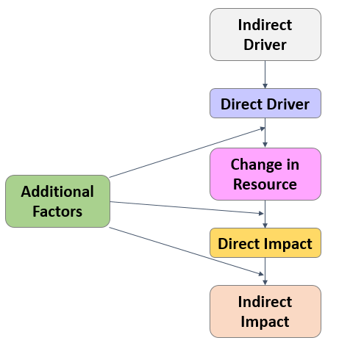
Figure 1. The proposed conceptual framework template for assessing system processes and changes

The template is modular in nature, so that diagrams can be readily combined to capture multiple system processes and complex pathways of influence. As multiple diagrams are combined, impacts from a change in one resource may become drivers for change in another resource. The template allows divergent ideas from the team to be mapped out and linked together in one common framework, facilitating a genuinely transdisciplinary process.
Integrated modelling, integrated assessment frameworks, conceptual model

